2024 VCE Music Contemporary Performance written external assessment report

General comments
The 2024 VCE Music Contemporary Performance examination consisted of two sections: Section A – Listening and interpretation and Section B – Music language. The overwhelming majority of students attempted all questions.
Section A – Listening and interpretation involved listening to three previously unheard works and analysing the ways the performers used the music elements, concepts and compositional devices. A comprehensive understanding of the music elements, concepts and compositional devices found in the cross-study specifications was required (pages 15–19 of the study design). The ability to describe, discuss or compare the interpretative decisions made by performers was also required, together with knowledge of the resultant musical character or stylistic characteristics of the work.
Students should begin consistent practice in using the music elements, concepts and compositional devices to describe what they hear from the beginning of Unit 1 and continuing throughout Units 2, 3 and 4, and this should occur in relation to all areas of study and outcomes. Following frequent and regular sessions discussing (verbally and in writing) how performers interpret and manipulate the music elements, concepts and compositional devices in contemporary performance, students can, over time, be introduced to completing written responses with time constraints, as per the examination conditions.
Students should read the questions carefully to ensure they are addressing the key ideas raised in the question. For example, students should note whether the question requires them to address particular music elements, concepts and compositional devices (Question 1b.), or whether there is a free choice (Question 1a.), or whether there is a choice within several options (Question 2). Students should also read the question carefully to see if they are asked to discuss how the performers create musical character (Question 1b. and Question 2) or style (Question 1a.) in their response. Some students highlighted or underlined the key terms in the questions to assist with this, which is a useful habit for students to develop.
Students do not need to repeat the question as an opening statement in their response.
Very good responses tended to include subheadings for the specific elements of music. Bullet points were also useful, enabling students to write concisely, be specific and clearly address the question. Higher-scoring responses were able to link the music elements, concepts and compositional devices to the musical character or style. Students need to ensure that the link is logical. For example, it is not self-evident that a clean guitar tone creates a romantic character.
The highest-scoring responses in Section A demonstrated a sophisticated understanding of the way the music elements, concepts and compositional devices were used, and this was clearly linked to specific musical evidence and made use of appropriate contemporary music terminology.
Overall, students were generally able to highlight the musical character successfully, but greater attention needs to be given to how the music elements, concepts and compositional devices contribute to the identified character. Students should become familiar with a range of vocal and instrumental techniques commonly found in contemporary performance and be able to use contemporary music terminology appropriately. This includes elements and concepts such as vocal and instrumental sound sources and sound production methods, with associated terminology specific to contemporary music performance, in a range of styles and genres.
For Section B – Music language, many students used a sharp pencil, which is strongly advised. Students should take great care when completing the music documentation, and ensure there is no ambiguity in the pitch or rhythm when writing notes on the staff or completing the graphic notation. When undertaking transcription questions using staff notation, students are advised to complete their rough work on the blank manuscript paper provided and then transfer a neat, legible copy of their final response to the space provided for the answer.
Students should provide only one response for transcription questions in which they are asked to document the missing notes by drawing on the staff or writing letter names or completing the rhythm grid.
Where possible, students should have access to appropriate aural training software and a Digital Audio Workstation (DAW), especially to sequence rhythms, chords and chord progressions for aural practice.
Regular class singing and playing of melodies and chords and performance of melodies and rhythms is highly recommended to develop an understanding of the connection between the sound and the musical documentation, ideally using a ‘little and often’ and ‘sound before symbol’ approach.

Specific information
Note: Student responses reproduced in this report have not been corrected for grammar, spelling or factual information.
This report provides sample answers or an indication of what answers may have included. Unless otherwise stated, these are not intended to be exemplary or complete responses.
The statistics in this report may be subject to rounding resulting in a total more or less than 100 per cent.

Section A – Listening and interpretation

Question 1a.
Mark | 0 | 1 | 2 | 3 | 4 | Average
% | 0.7 | 17 | 42 | 30 | 10 | 2.3
This question was broad, allowing students to draw on one or more of the elements and compositional devices listed, or to choose element(s), concept(s) or compositional device(s) not listed, to describe how the performers interpreted and manipulated elements and concepts to create the contemporary jazz style.
Higher-scoring responses made links between specific characteristics of the style that could be discerned aurally and the musical characteristics of the excerpt. The highest-scoring responses included a detailed and coherent description of how performers interpreted and manipulated elements and concepts to achieve stylistic characteristics.
A somewhat common error was that some students did not read the question carefully and wrote about how the performers created musical character instead of style. Underlining key words in the question may help students to avoid this error.
This question highlighted the need for students to consistently practise using the music elements, concepts and compositional devices found in the cross-study specifications, as well as music terminology specific to contemporary music performance, when responding to music. Students are encouraged to practise this with previously unheard excerpts in a range of styles as well as their own and their peers’ performance pieces in Units 3 and 4, and across all areas of study and outcomes in Units 1 and 2.
The following are examples of possible relevant points.
Tone colour:
- expressive, muted, mournful trumpet
- dry brushes on snare drum; drum kit playing is whispery
- twinkling piano
- change in feel halfway through – light clean hi-hat, mellow female vocal, warm mid-tone guitar
- clean guitar sound with improvised picked melodies towards the end of the excerpt
- instrumentation typical of contemporary jazz: trumpet, piano, guitar, drums, bass, vocal
Articulation:
- use of legato, slurs, accents, vibrato (on trumpet), slides, bends, grace notes
- marcato (short accents)/staccato in trumpet in the transition section
- legato piano, sustain pedal
- change of feel halfway through excerpt, through more accented and staccato phrasing, particularly on trumpet and piano
- piano – mix of gentle chords, smooth legato phrasing, to faster and accented phrasing moments in response to trumpet and then vocal phrases
Dynamics:
- generally moderately loud (mezzo-forte) with limited variation
- some dynamic variation in transition section in the middle of the excerpt, with more use of accents and swells
- each phrase in the opening trumpet solo generally reducing in volume (decrescendo) towards end
- vocal phrases also tending to crescendo and then decrescendo
- accompanying instruments – piano, guitar, bass, drum kit – generally moderately soft (mezzo piano) to support trumpet and then vocal melody
- drum kit in a supporting role, unobtrusive dynamic level throughout, light accents on 2 and 4 in vocal section
Duration (rhythm, metre, beat, pulse, tempo):
- characteristic swing feel, long and short quavers, off-beat emphasis, particularly noticeable at the slow opening tempo
- tempo (speed) fairly slow, approximately 70 bpm at the beginning, almost half-tempo feel
- 4/4 metre, swing feel
- pause in the middle of the excerpt
- slightly faster tempo in the second part of the excerpt when the vocalist enters, approximately 100 bpm
- variety of tempos and feels, typical of contemporary jazz
Texture:
- excerpt beginning with piano, drums, bass, solo trumpet
- vocalist entering after transition section, guitar entering towards end of excerpt
- first section, solo trumpet melody improvised, second section vocal melody
- drums and bass playing similar accompanying role throughout
- piano playing melodic ideas interspersed with the trumpet and vocal melody, also providing harmonic and rhythmic support
- rhythmic unison in transition section – trumpet and piano
- question and answer / call and response between melodic instruments – trumpet and then voice – and piano and guitar (towards end of excerpt)
Transition:
- three sections: introduction with improvised and embellished trumpet solo with piano, drum kit and bass; transition section with tempo variation, slowing to a pause; then new tempo introduced via drums
- dramatic variety from the tempo variation and pause typical of contemporary jazz style, adding complexity and expression
Many very effective responses used subheadings and bullet points to address each element separately, however subheadings and bullet points weren’t necessary for a response to score highly.
The following is an example of how a high-scoring response addressed duration and tone colour.
The slow tempo in the beginning creates a moody character, creating the sound of a contemporary jazz ballad. The brassy bell-like tone colour and swung quavers, articulated with accented notes on off-beats creates the quintessential swing feel for the jazz style. The breathy tone colour and stirring brushes on the snare drum contributes further to the swing style. The rhythm section texture comprises of standard contemporary jazz layers. The horns articulations of staccato to forte once the new groove comes in contributes to the relaxed mood that is conventional of the contemporary jazz style.

Question 1b.
Mark | 0 | 1 | 2 | 3 | 4 | Average
% | 1 | 21 | 42 | 29 | 7 | 2.2
This question required students to discuss how the performers used both vocal and instrumental sound sources and articulation to create musical character.
Most students answered this question successfully, although some students did not read the question carefully, focusing on only one of tone colour and texture. Some students did not identify the musical character. Students should read the question carefully to ensure they are addressing all the requirements of the question.
The highest-scoring responses were able to make points addressing how the performers used both instrumental sound sources and articulation, and link this to how the performers created musical character.
Some students struggled with the articulation aspect of this question, and did not use the specific contemporary music terminology needed.
The following are examples of possible relevant points.
Character:
- relaxed, warm, leisurely musical character
Vocal and instrumental sound sources:
- introduction – expressive, muted, mournful trumpet, piano, drums, bass
- drums using brushes – providing sense of pulse and light accents on beats 2 and 4
- piano playing supporting role – providing harmonic support via chords and melodic lines
- change in feel halfway through – light, clean hi-hat, mellow female vocal, warm mid-tone guitar
- female voice entering halfway through, making use of rubato; warm and melancholic character
- clean electric guitar taking over the piano role, with melodic ideas towards end of excerpt
Articulation:
- use of legato, slurs, accents, vibrato, slides, bends, grace notes on trumpet, creating muted, slippery effect contributing to the relaxed character
- marcato (short accents)/staccato trumpet and piano in transition section

- sustain pedal on piano, legato, change in feel halfway through to be more accented and staccato
- drums – smooth and sustained sound with brushes, helping blend with other instruments; light accents on beats 2 and 4
Many very effective responses used subheadings and bullet points to address each element separately.
The following is a good example of a response that addressed all aspects of the question.
Vocal and instrumental sound sources
- The female vocalist uses an aspirate onset with somewhat unclear, conveying a relaxed attitude which fits well with the overall character
- Use of vocal fry is evident at the lowest register, contributing a sense of yearning, while minimal melisma and slight reverb reinforces the calm
- The rhythm section consisting of bass, drums, piano, and subtle guitar comping provides a foundation for the trumpet and subsequent vocal melody to sit on top of the groove
Articulation
- In the ‘A’ section, note lengths are longer with both the brushes and long decaying piano chords complementing the solemn, legato trumpet melody
- However, the upbeat shift into the ‘B’ section yields shorter note lengths which adds excitement.
- In particular the staccato dotted crotchet played by the trumpet and piano followed by a longer note contributes to the more driving mood

Question 2
Mark | 0 | 1 | 2 | 3 | 4 | 5 | 6 | 7 | 8 | 9 | 10 | 11 | 12 | Average
% | 0.1 | 0.7 | 4 | 9 | 16 | 19 | 18 | 14 | 10 | 5 | 3 | 2 | 0.6 | 5.8
This question required students to compare the ways in which two interpretations created different musical characters. In their responses, students had to refer to three of the following: structure, vocal and instrumental sound sources, sound production methods, texture, pitch and transition.
Responses presented comparisons in a range of formats, and various approaches were all effective. Some students used bullet points to list points that were evident in each interpretation. Others used a two-column format, aligning the descriptions of the specific features of each interpretation. The highest-scoring responses made a clear comparison between the two interpretations, giving specific examples of how the elements of music and compositional devices were used to create musical character.
To prepare for the examination, students need to develop a vocabulary of specific terminology for a range of contemporary music performance styles associated with each of the music elements, concepts and compositional devices.
Interpretation B artists, King Stingray, describe themselves as a Yolŋu surf rock band with Yolŋu (Aboriginal people from north-eastern Arnhem Land) and non-Indigenous musicians. This track includes the Aboriginal and Torres Strait Islander instruments of didgeridoo/yidaki and clapsticks. Post-1990 Australian music is a focus of the study design, which includes music by Aboriginal and Torres Strait Islander artists. If students don’t know the specific names of instruments, the Country that the musicians are from or the language they are singing in, then appropriate terms to describe peoples, instruments and languages are: Aboriginal and Torres Strait Islander, First Nations, or Indigenous, all of which should be capitalised. Other terms are not appropriate and should not be used.

The following are examples of possible relevant points.
Musical character:
- Interpretation A: tongue in cheek, quirky, anthemic
- Interpretation B: bright, joyous
Structure:
- Interpretation A: intro/solo (flute), verse, chorus, bridge/solo (guitar and flute), verse
- Interpretation B: intro (didgeridoo/yidaki), then drums and guitar referencing the original chorus, verse (in language – Yolŋu Matha and English), chorus, bridge
Vocal and instrumental sound sources:
- Interpretation A: drums, flute – mid register, lead vocals – male voice, lower register in verse 1, mid register in chorus, mid-upper register in verse 2 which adds intensity, backing vocals, bass, guitars, percussion – shakers and timbales
- Interpretation B: didgeridoo/yidaki, clapsticks, drum kit, electric guitars, bass, male vocals
Sound production methods:
- Interpretation A: solid kick/snare driving, rhythm section – drums and bass holding the groove, guitars – chorus effect, some delay in lead lines, lightly overdriven guitars, double-tracked guitars, vocal layering and harmonies, acoustic flute with reverb
- Interpretation B: heavily distorted guitars, especially in the chorus and post-chorus, guitar layers and overdubs, double-tracked guitars, guitars drive the track, vocal layers (lower harmony leading into chorus), vocal reverb, post-chorus in Yolŋu Matha with many layers of vocals and guitars, reverb on didgeridoo/yidaki, drum fill with reverb
Texture:
- Interpretation A: lines intertwine rhythmically between instruments, flute and vocals in the foreground, bass guitar back in the mix, guitar sometimes in foreground but mostly in background supporting the vocals
- Interpretation B: layers of instruments and vocals creating a ‘wall of sound’ in certain parts, distorted guitars with a variety of strumming patterns and tremolo creating thick and boomy sound, dark drone of the didgeridoo/yidaki contrasts with percussion and vocals
Pitch:
- Interpretation A: somewhat atonal/untuned percussive sounds in intro, vocal harmonies in chorus, embellished and ornamented flute melody contrasting with smaller range of vocal melody, simple and narrow-range vocal melody in verse
- Interpretation B: verse vocal higher in pitch than original, post-chorus high vocals creating tension, iconic Aboriginal vocal techniques used to embellish the original melody and harmonies, wider range overall, particularly with added harmonies and vocal lines
Transition:
- Interpretation A: transitions between sections led by drum fills, chorus transition into the solo very clear – marked by the change in strumming in the guitar part
- Interpretation B: sonic changes between verse and chorus loud/soft, less/more, not distorted/distorted, transitions identified by percussion cues or didgeridoo/yidaki, bridge section at the end of the chorus containing new material not found in original
Many very effective responses used subheadings and dot points to address each element separately.

The following is a good example of a response that addressed the question using a two-column structure, sub-headings and dot points.
Texture (Interpretation A)
- Thick texture. Layers of heavy bass, drums and guitar create this texture.
- Instrumental section, flute motif is supported by drums and bass which creates a fuller sound
- In instrumental section, there is an element of antiphony between electric guitar and flute which creates an energetic mood and feel
Texture (Interpretation B)
- Dense texture due to layering of didgeridoo, thick electric guitar, bass and drums
- In chorus, electric guitar adds to thickness of texture due to its distortion
- Texture grows from sparse feel at the very beginning with isolated didgeridoo and then grows as more layers such as percussion are added
- Harmonies over vocals in verse add to thick texture
Pitch (Interpretation A)
- Repeated motif played by flute creates a catchy and bright effect
- Very steady and straightforward melody that can be easily sung along to
- In singers lower to mid vocal register
Pitch (Interpretation B)
- In instrumental section, vocals are played over the top in legato style to contrast melody in verse and chorus
- Repeated motif played on didgeridoo which creates a deep and brooding feel
- Second set of vocals sing an octave higher at times to enhance melody
Structure (Interpretation A)
- Introduction – steady tempo, repeated motif on flute
- Verse/chorus – dynamically very similar, no complex rhythms
- Instrumental – drum fills used to contrast flute playing. Bass is stronger in this section
- Verse – not much vocal variation
- Structure can be easily followed
Structure (Interpretation B)
- Intro – begins with didgeridoo by itself, immediately followed by percussive instruments, building to the verse
- Verse – vocals are rough and raspy
- Chorus – addition of heavy distorted guitar, drums. Dynamically louder than verse.
- Instrumental – vocals over the top creates fullness
- More complex structure

Section B – Music language

Question 3a.
Mark | 0 | 1 | 2 | Average
% | 26 | 40 | 34 | 1.1
- first interval: perfect fifth
- second interval: major second
The majority of students identified the intervals. To obtain the mark, both quality and quantity needed to be correct. To prepare for the examination, students should practise hearing and identifying intervals that are presented harmonically as well as ascending and descending.
Students must avoid using ‘M’ or ‘m’ to indicate intervals, as this is unclear; they should instead write ‘minor’ or ‘major’. If the interval was not clearly identified, it was deemed incorrect.

Question 3b.
Mark | 0 | 1 | 2 | Average
% | 21 | 34 | 46 | 1.3
- first interval: minor sixth
- second interval: perfect octave
The majority of students correctly identified the intervals. Most students correctly identified the quantity; however, quality was more challenging for the perfect octave. Students needed to identify both quantity and quality to obtain the mark.
To prepare for the examination, regular singing, playing and documenting of all diatonic intervals in a ‘little and often’ and ‘sound before sign’ approach, both in context and in isolation, is recommended.

Question 4a.
Mark | 0 | 1 | 2 | Average
% | 11 | 36 | 54 | 1.4
- first scale or mode: blues
- second scale or mode: aeolian
Most students correctly identified the scales or modes.
To prepare for the examination, regular singing, playing and documenting of scales and modes in a ‘little and often’ and ‘sound before sign’ approach, both in context and in isolation, is recommended.

Question 4b.
Mark | 0 | 1 | 2 | Average
% | 28 | 46 | 25 | 1.0
- first scale or mode: dorian
- second scale or mode: major pentatonic
Most students correctly identified one or both of the scales or modes. Some students confused dorian for mixolydian. To prepare for the examination, students should practise identifying the scale degree three as the note that differs between these two modes.
Regular singing, playing and documenting of scales and modes in a ‘little and often’ and ‘sound before sign’ approach, both in context and in isolation, is recommended.

Question 5
Mark | 0 | 1 | 2 | 3 | 4 | 5 | 6 | 7 | 8 | Average
% | 5 | 6 | 5 | 27 | 15 | 14 | 9 | 4 | 15 | 4.3

Students were asked to document the missing notes by either drawing the notes on the stave or writing letter names in the empty boxes.
Many students found this question challenging.
Students are encouraged to use the information given; for example, the first three pitches of the missing documentation were the same as the first three pitches in the previous bar. Students also needed to look at the chord symbols given to identify chord tones, as missing pitches 4–8 were all chord tones.
Some students both documented the pitches on the stave and wrote letter names; in this case, only the first response was assessed, which was the pitches on the stave. It is important for students to read the questions carefully.
Students who use the stave need to write neatly and carefully, clearly indicating which notes are on a line or in a space. Some students did not clearly indicate whether notes were on a line or in a space, and when this was unclear, their response was deemed incorrect.
To prepare for the examination, regular singing, playing and documenting of short melodies in a ‘little and often’ and ‘sound before sign’ approach is recommended. This should include examples both in context and in isolation. In contemporary music, learning by listening and copying recordings by playing is a common way of learning; this can be extended to include documenting short melodic ideas. This approach should be encouraged to develop the aural skills required for this question type.

Question 6
Mark | 0 | 1 | 2 | 3 | 4 | Average
% | 17 | 23 | 21 | 21 | 19 | 2.0
- first triad/chord: dominant seventh
- second triad/chord: diminished
- third triad/chord: major
- fourth triad/chord: suspended fourth

Responses generally showed a reasonable command of triads/chords.
The recognition of the seventh in the first chord proved challenging for many students. For the first chord, some students identified a major seventh; this chord is a major chord with a major seventh above the root, whereas a dominant seventh chord is a major chord with a minor seventh above the root note.
To prepare for the examination, regular singing, playing and documenting of triads and chords in a ‘little and often’ and ‘sound before sign’ approach is recommended.
Learning by listening and copying recordings is another effective approach common in contemporary music that is also recommended for developing aural skills and the ability to hear vertically (harmonically) as well as horizontally (melodically).

Question 7
Mark | 0 | 1 | 2 | Average
% | 29 | 20 | 51 | 1.2

3 | 4
I | V
Most students handled this question well. To prepare for the examination, students should practise identifying the common chord progressions listed in the study design and to identify missing chords within these progressions. There are only a limited number of chord progressions given in the study design, which assists students in identifying the missing chords in the examination.
Students should regularly practise recognising chords as part of a chord progression. Regular singing, playing and documenting of chords and chord progressions in a ‘little and often’ and ‘sound before sign’ approach, both in context and in isolation, is recommended. In contemporary music, learning by listening and copying recordings is a common learning approach that can be used to practise identifying chords and chord progressions. These approaches will help students develop the aural skills required for this type of question.

Question 8
Mark | 0 | 1 | 2 | 3 | 4 | Average
% | 11 | 13 | 15 | 19 | 41 | 2.7
- first triad/chord: C Eb G Bb
- second triad/chord: G D
- third triad/chord: A C# E
- fourth triad/chord: F A C Eb
This question was generally answered well. Students were required to write the letter names of the chords. A small number of students wrote the accidental before the chord and this was deemed incorrect; students should write the accidental after the letter name, following the example given in the question. Note that enharmonic equivalents such as D# instead of Eb are not correct when writing chords, and responses using these were deemed incorrect.
The regular singing, playing and documenting of chords previously recommended would also be of assistance here.

Question 9
Mark | 0 | 1 | 2 | Average
% | 6 | 30 | 64 | 1.6
- first rhythmic feel: straight 8ths
- second rhythmic feel: swing
While most students answered this question well, there were some students who found this question challenging. To prepare for the examination, students should practise identifying (and recreating) a range of rhythmic feels found in contemporary performance; some examples are given in the study design. Activities such as listening, playing, creating and improvising will help with developing this knowledge.

Question 10
Mark | 0 | 1 | 2 | 3 | 4 | Average
% | 8 | 18 | 20 | 21 | 32 | 2.5
The fragments were heard in the following order: E C A B.
This question was generally answered well, with most students identifying at least two of the fragments in the correct order. A helpful tactic for students is to memorise the missing rhythm when it is played, so that they can ‘replay’ the rhythm in their heads during the silent working time.
As this question was multiple choice and it was played six times, students may also find it useful to focus on listening for the presence of one missing fragment for each playing.

Question 11
Mark | 0 | 1 | 2 | 3 | 4 | 5 | 6 | 7 | 8 | Average
% | 7 | 12 | 16 | 17 | 14 | 11 | 7 | 5 | 13 | 3.8
Correct responses included any one of the following:
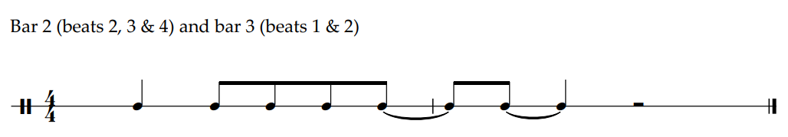
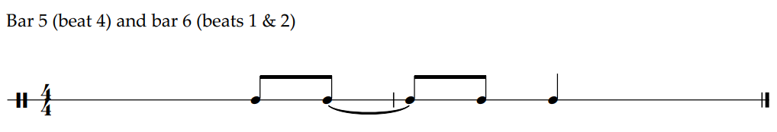
OR
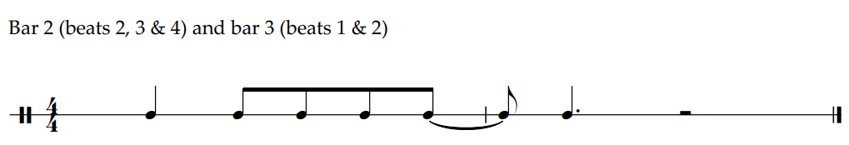
OR
OR
Bars 2 and 3 Bars 5 and 6
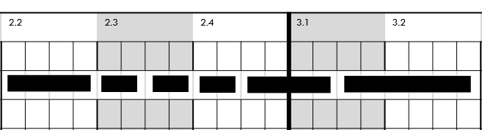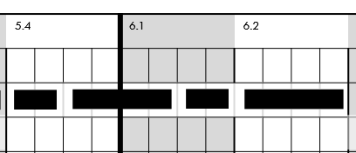
OR
Bars 2 and 3 Bars 5 and 6
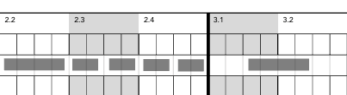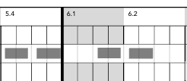
OR
Bars 2 and 3 Bars 5 and 6
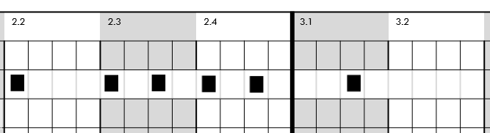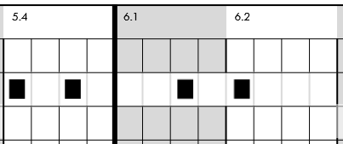
Students were asked to transcribe the missing notes in an excerpt by either drawing the notes on the stave or drawing in the rhythm grid. Many students chose to respond using the rhythm grid, a method of documentation that is a new option in this study design.
Students are reminded to read the question carefully; some students both transcribed the pitches on the stave and drew in the rhythm grid. In this case, only the first response was assessed, which was the staff notation.
Students should write neatly and carefully and use a sharp pencil for this question. Some students who responded using the rhythm grid did not clearly indicate whether the first note in bar 5 began on beat 1 or was held across from the previous bar. When this was unclear, the response was deemed incorrect.
To prepare for the examination, students should practise a range of forms of documentation appropriate to contemporary music performance, to gain fluency and confidence with a variety of documentation approaches before responding to these types of questions under the time pressures of the examination.
Regular singing, playing and documenting of short rhythmic ideas in a ‘little and often’ and ‘sound before sign’ approach is recommended. This should include examples both in context and in isolation. In contemporary music, learning by listening and copying recordings is a common way of learning; this can be extended to include documenting short rhythmic ideas. This approach will also develop the aural skills required for this question type.

